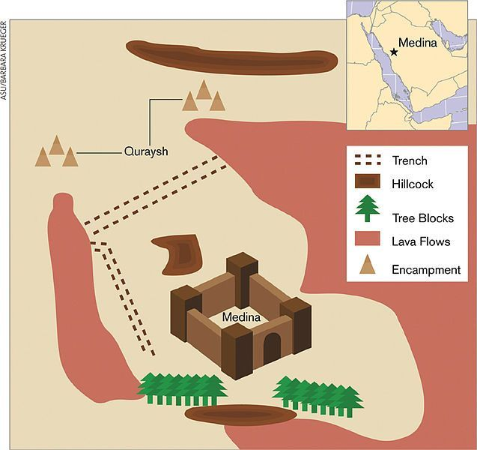
🌙 Ghazwa-e-Khandaq ki Kahani

✅📍 Background (Peesha Manzar)

Rasoolullah ﷺ aur Sahaba Madinah mein sukoon se Islam phaila rahe the. Lekin Quraysh aur unke saathi dushman Islam ko mitana chahte the. Uhud ke baad unhone tay kiya ke ek **bohot badi lashkar** banakar Madinah par hamla karein. Quraysh ke saath Ghatfan aur aur bhi Arab qabail mil gaye – taqreeban **10 hazaar sipahi** tayar hue.

✅🏰 Musalmanon ki Strategy

Madinah chhoti thi aur Musalman sirf **3 hazaar** the. Itne bade lashkar ka samna karna mushkil tha.
Us waqt ek Sahabi **Hazrat Salman Farsi (RA)** ne mashwara diya:
👉 "Hum apne shahron ko bachane ke liye **khandaq (khayi)** khodte the, aap bhi Madinah ke aas paas khandaq khod dein."

Ye naya tareeqa tha jo Arab ke liye ajnabi tha. Nabi ﷺ ne mashwara pasand kiya aur sab Sahaba milkar **5 kilometer lambi, gehri aur chauri khandaq** khodne lage. Sardiyon ke din the, bohot mushkil kaam tha, lekin sab ne jazbe se kaam kiya.

✅ ⚔️ Lashkar ka Hamla

Jab Quraysh aur unke saathi Madinah pohonche, unhone khandaq dekhi aur heran reh gaye!
Horses aur sipahi us khayi ko paar nahi kar sakte the. Kai din wo khandaq ke samne ruk gaye.

Dushman kabhi tir chalaata, kabhi galiyan deta, kabhi paara karne ki koshish karta – lekin Musalman uska jawab dete. Kuch jagah unhone cross karna chaha, lekin **Hazrat Ali (RA)** ne bohot bahaduri se ladkar wapas bhaga diya.

✅🌪 Allah ki Madad

Ye siege (gherao) bohot din tak chala. Musalman bhook, sardi aur mushkilat se guzre. Lekin Allah ne madad faraham ki:

* **Tez hawa (storm)** chal gayi jisne Quraysh ke kheme, bartan aur aag bujha di.
* Lashkar mein afra-tafri mach gayi.
* Akhirkar wo thak kar wapas chale gaye, bina kuch hasil kiye.

✅🕌 Natija

Ye jang **Rasoolullah ﷺ ke khilaf sabse bada hamla tha**, lekin Allah ki hikmat aur Musalmanon ke jazbe se dushman nakaam ho gaye.
Nabi ﷺ ne farmaya:
👉 "Ab se Quraysh hum par hamla nahi karenge, ab hum unpar hamla karenge."

✅ 🌟 Seekhne Wali Baatain

1. **Mashwara aur teamwork** se chhote log bhi bade dushman ka samna kar sakte hain.
2. **Sabr aur yaqeen** mushkil waqt mein Allah ki madad ko bulata hai.
3. **Planning aur aqalmandi** sirf taqat se zyada important hai.

